**Outputs (22-feb-2024)**

1. Output **:- WAP to create a simple calculator program that takes user input for two** numbers and an operator (+, -, *, /) and performs the corresponding arithmetic operation using conditional statements.

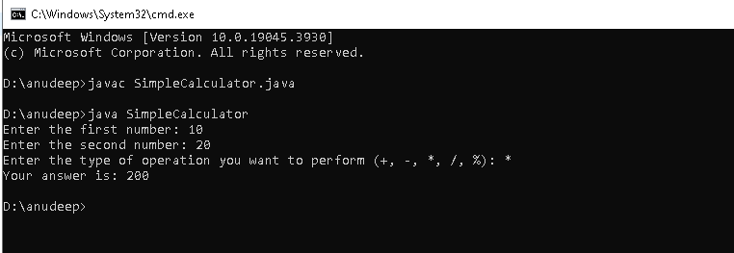

2.Output :- Create a class named Book with attributes title, author, ISBN, and price. Include methods to get and set the attributes.

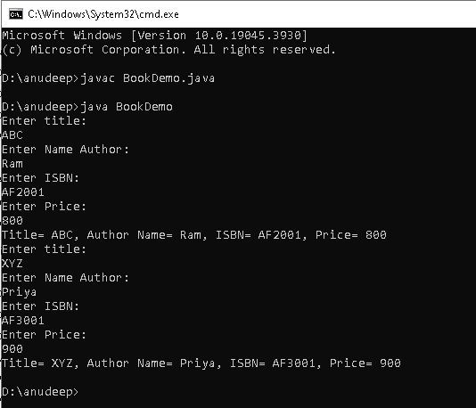

3.Output :- create a class named Employee with attributes name, employeeid, designation and salary. include a method calculateBonus() that returns 5% of the salary as bonus.

